EXERCISE NUMBER:1
DATE:10/10/2020
Aim:To write a Python program to print the calendar of a given month and year
PROGRAM:
import calendar
year=int(input())
month=int(input())
if(year<10000 and year>999 and month<13 and month>0):
print(calendar.month(year,month))
else:
print("Invalid Input")
Link: http://103.53.53.18/mod/vpl/forms/submissionview.php?id=230&userid=1746

Output:

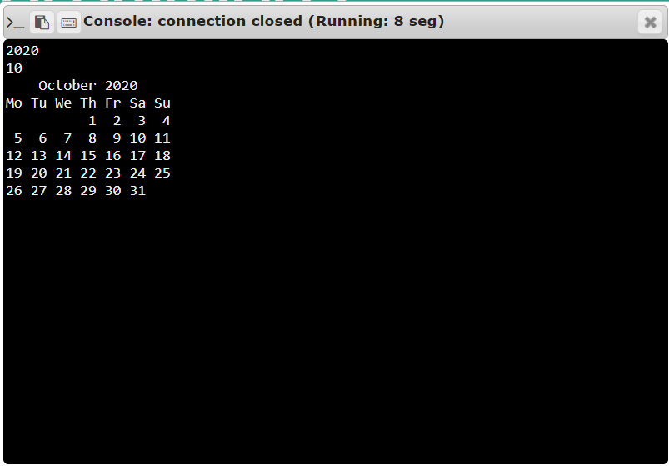
Result:The output of this program is verified.

